

CommandCentral DEMS
Ordering Guide

LAST UPDATED 4/24/2026

Table of Contents

Table of Contents 2
General Product Information 3
System Configuration 4
Software Service Tiers 4
Model Selection 4
Provisioning Cloud Information 5
Storage 7
Geo-redundant 7
Storage Type 7
3rd Party Storage Type 9
CPQ Screenshot: 9
Upload Appliance (optional) 10
Product Integrations (optional) 11
Professional Services 12
System Integration Calculation 12
Deployment Type 13
Deployment Options 14
Video Deployment (SI) Services 14
Deployment Services (total project dollars) 15
Deployment Services (Optional Selection) 16
CommandCentral DEMS Training Services 17
Learning Subscription 18
Required Order Information 19
Interfaces (3rd Party Integrations) 20
Edge Device Options 22
Accessories 24
Helpful Links 25
MSAC (FedRAMP) DEMS Service Part Numbers: 26
CCCS DEMS Service Part Numbers: 26

General Product Information

CommandCentral DEMS provides a suite of digital evidence management tools that help users contain, organize, and act on large amounts of incoming multimedia. These tools streamline the collection, capture, storage, and sharing of data from a single location.
Select Solution Description links below for more information about each tier.
Solution Description Starter
Solution Description Standard
Solution Description Plus
Solution Description Device Management Only

DEMS Internal Training & Resources

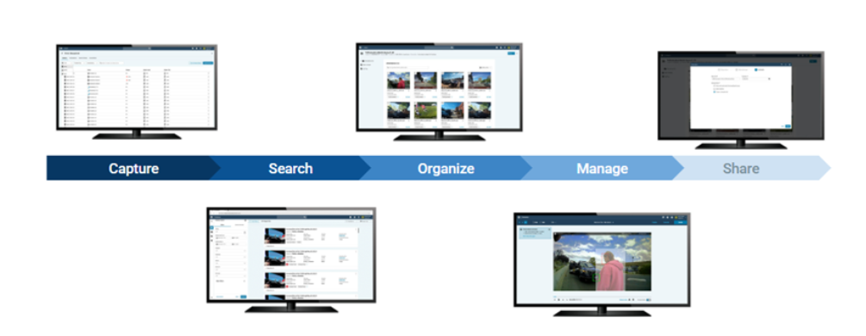

Benefits:
- Device management
- Collections
- Redaction with AI Assist
- Automated transcription
- Secure sharing

System Configuration

Software Service Tiers
A user can select from Starter, Standard, Plus or Device Management Only. See this Internal Sales Guide for further details on each tier.

PRICING NOTE: The pricing for Software Services is determined by the number of devices uploading video to DEMS, regardless of whether they are new, existing, Motorola-branded, or from a third-party vendor.
For customers such as a DA Office that do not track video uploads by individual device, please enter the total number of Users into the "# of Devices" field during the ordering process.

Model Selection

Part Number | Description | Price | APC
SSV00S05155A | STARTER  Search, View, Download files, Collections Lite  The Starter tier does not include Device Management. For customers needing device management and evidence management, the Standard or Plus package is required. | $0 | 696
SSV00S05157A | STANDARD  Device Management, Collections, Sharing, Redaction (manual), SmartControl, 1P CAD Auto Tagging, Responder Light | $20/ Device/ Month | 696
SSV00S05158A | PLUS  3rd Party Data Upload, AI Redaction, AI Auto Transcription, Automated Access Management | $33/ Device/ Month | 696
SSV00S05534A | DEVICE MANAGEMENT ONLY  Used only for SVX RSM Only Customers.  Includes PSV00S05316A SmartDock Config Service @ $0 | $0 | 696
To view DEMS Service Tier part numbers for FedRAMP & CCCS click Here.

CPQ Screenshot:
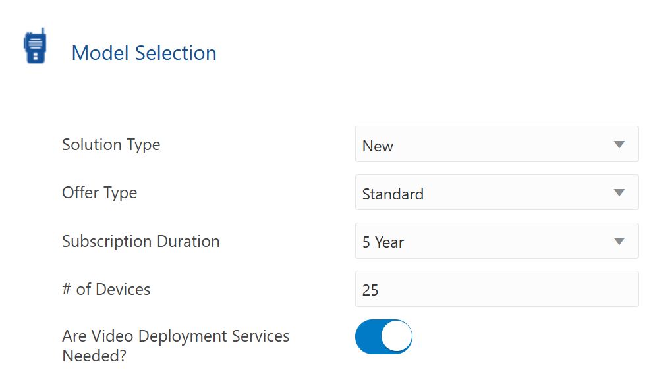

- Solution Type: Select New for new DEMS agencies and Expansion if adding services for existing agencies. Select Transition for customers transitioning from VMEL to DEMS.
- Offer Type: Select desired Software Service Tier.
- Subscription Duration: Select duration 1-10 years.
- # of Devices: Enter the number of Camera Devices* for the agency. This is any bodyworn or in-car camera system.
*For customers such as a DA Office that do not track video uploads by individual device, please enter the total number of Users into the "# of Devices" field during the ordering process.

- You can toggle the “Are Video Deployment Services Needed?” Off to reduce the questions shown in the configuration if you are selling the DEMS software without video devices. SVX devices purchased as RSM only do not require Video Deployment services.

Provisioning Cloud Information
DEMS is currently available in three environments:
- US Gov Cloud
- Motorola Solutions Authorized Cloud (MSAC): This is the FedRAMP authorized environment. DEMS is FedRAMP High Authorized
- Canada Cloud: DEMS is CCCS Assessed
For more information about Motorola Solutions Environments.

If “No” is selected, DEMS will be provisioned in the Motorola Solutions US Gov cloud except for Canadian customers who will automatically default to CCCS.
Motorola does not support a two-cloud operating environment. All devices, new orders or existing (fielded), must either reside in the U.S. Gov cloud, or the Motorola Solutions Authorized Cloud (MSAC). Customers cannot have devices provisioned and operating in both cloud environments at the same time.
If “Yes” is selected, DEMS will be provisioned in the Motorola Solutions Authorized Cloud.
IMPORTANT: Prior to submitting a quote, please confirm the customer is currently deployed in the Motorola Solutions Authorized Cloud (MSAC), or is eligible for a new deployment in the MSAC (e.g., customer is a U.S. government entity with appropriate authorization to operate (ATO) in the MSAC). Migrating customers back to the U.S. Gov cloud will result in increased cost for MSI and a delay in the usage of devices and application services.
The Sales representative must enter a valid email address. The quote will not be processed unless a valid email address is provided.
CPQ Screenshot:

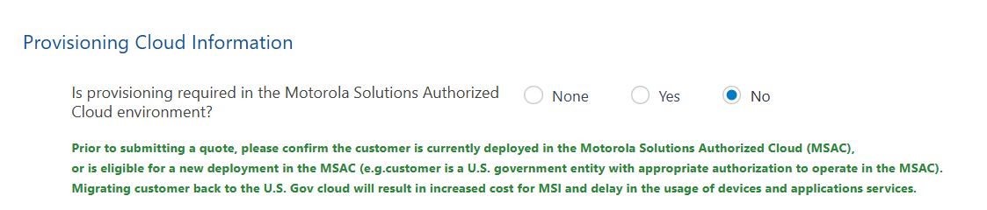

Storage

Geo-redundant
Geo-redundant storage is mandatory for MSAC (FedRamp) and optional for other environments (US Gov & CCCS). This is the duplication of customer data across physically separate, geographically dispersed locations. If a primary data center fails due to natural disasters or major outages, the secondary, remote location can take over, preventing data loss and ensuring business continuity.

Selecting “Yes” for “Is Geo-Redundant Storage required?” if the customer requires Geo-Redundancy. This selection will determine the storage part numbers and pricing selected below.

CPQ Screenshot:
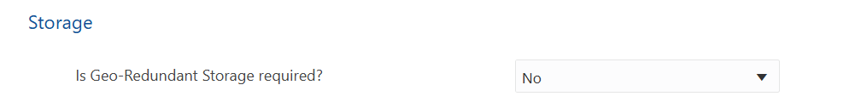

Storage Type
Use this selection for Motorola video storage, see 3rd Party Storage type to select storage options for data from other vendors.
Select the Unlimited storage option and specify the total number of cameras for each system type, or select the Fixed storage option and specify the number of terabytes (TBs) needed. When quoting for a DA office, use the Fixed Storage option only.
NOTE: Unlimited storage is sold by Camera not video system. For example, an in-car video system with front and rear cameras would be a total of 2 Cameras for storage.
Part Number | Description | Price | APC
SSV00S05160A | UNLIMITED STORAGE PER BODYWORN CAMERA | $17/ Camera/ Month | 696
SSV00S05161A | UNLIMITED STORAGE PER IN-CAR VIDEO CAMERA  Price is per camera for each in-car system | $17/ Camera/ Month | 696
SSV00S05162A | UNLIMITED STORAGE PER INTERVIEW CAMERA  Price is per camera for each interview system | $78/ Camera/ Month | 696
SSV00S05159A | EVIDENCE FIXED STORAGE PER TB | $20/ TB/ Month | 696
SSV00S06292A | COMMANDCENTRAL DEMS FIXED  GEO-REDUNDANT STORAGE PER TB | $66.29/ Camera/ Month | 696
SSV00S06293A | COMMANDCENTRAL DEMS UNLIMITED GEO-REDUNDANT STORAGE PER BODYWORN CAMERA | $37/ Camera/ Month | 696
SSV00S06294A | COMMANDCENTRAL DEMS UNLIMITED GEO-REDUNDANT STORAGE PER IN-CAR VIDEO CAMERA | $74/ Camera/ Month | 696
SSV00S06295A | COMMANDCENTRAL DEMS UNLIMITED GEO-REDUNDANT STORAGE PER INTERVIEW CAMERA | $312/ TB/ Month | 696

CPQ Screenshot:
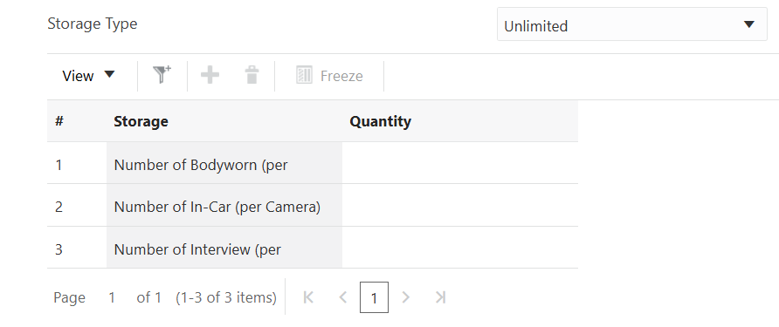

- Storage Type: Default is Unlimited, select Fixed if needed.
- Enter the number of Cameras by device type into the table.
NOTE: Unlimited storage is sold by Camera not video system. For example, an in-car video system with front and rear cameras would be a total of 2 Cameras for storage.
- The storage table will update if the Fixed storage type is selected to allow input for the number of TBs.

3rd Party Storage Type
Select the Unlimited storage option and specify the total number of Officers, or select the Fixed storage option and specify the number of terabytes (TBs) needed. When quoting for a DA office, use the Fixed Storage option only.

Part Number | Description | Price | APC
SSV00S05163A | UNLIMITED STORAGE 3RD PARTY  Non-Motorola media. For example: crime scene photos, files, other video etc | $26/ Officer/ Month | 696
SSV00S05535A | COMMANDCENTRAL DEMS FIXED 3RD PARTY STORAGE PER TB | $20/ TB/ Month | 696
SSV00S06296A | COMMANDCENTRAL DEMS UNLIMITED GEO-REDUNDANT STORAGE 3RD PARTY | $86.18/ Officer/ Month | 696
SSV00S06297A | COMMANDCENTRAL DEMS FIXED 3RD PARTY GEO-REDUNDANT STORAGE PER TB | $66.29/ TB/ Month | 696

CPQ Screenshot:

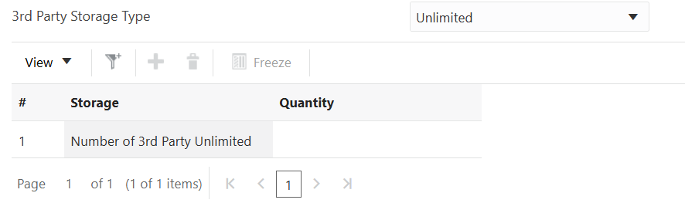

Upload Appliance (optional)
Compatibility for 4RE with DEMS is coming in March 2026. VISTA compatibility is TBD.
Upload appliance is a proxy component for evidence offload from 4RE and VISTA devices. For agencies using those devices it is a mandatory component for uploading the evidence to CommandCentral DEMS. For agencies using only next-gen M500, SVX and V300/V700 devices the Upload appliance is not required.
Additional consideration is the bandwidth available to the agency to upload the evidence to CommandCentral DEMS. In situations where bandwidth is limited, the Upload appliance serves as an edge device temporarily storing evidence before uploading it to the backend. This allows the devices to offload the videos quickly at the time of the end-of-shift network stress.

The Upload appliance can be deployed on premise as a physical server, or as a virtual server in the cloud. For agencies with next-gen M500, SVX and V300/V700 devices only, the Upload appliance ‘Virtual Cloud Server’ option does not bring any advantages to the system.

Part Number | Description | Price | APC
WGC01013 | Azure Virtual Upload Server  VM size: B2ms, 1TB staging, per Year | $125 /Server/ Month | 696
WGA00521-530 | Server, Upload, Rack, 3 Year Support | $7,440 | 9946
WGA00521-430 | Server, Upload, Tower, 3 Year Support | $7,630 | 9946
WGA00521-550 | Server, Upload, Rack, 5 Year Support | $8,190 | 9946
WGA00521-450 | Server, Upload, Tower, 5 Year Support | $8,010 | 9946

Upload appliance configuration (tower and rack):
- Intel Xeon processor
- 16 GB UDIMM RAM memory
- OS hard drive: 2x 480 GB SSD (RAID1)
- Data hard drives: 4x 960 GB SSD (RAID5)
  - 2.88 TB of usable space
  - Fault tolerance: 1-drive failure
- Network: dual 1Gb, dual 10Gb
- OS: Windows Server 2022 IOT

CPQ Screenshot:
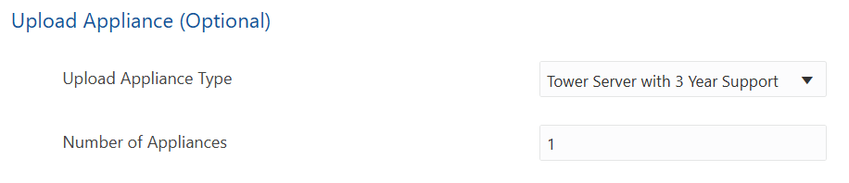

Product Integrations (optional)
Select desired Motorola product integrations. Please note, the Interview Streaming Application requires a Mobile Video deployment service to implement.

Integrations Data Sheet

DEMS <> MSI Integration (WORK IN PROGRESS)

NOTE: 3rd Party CAD and RMS integrations are quoted using the Interfaces CPQ tile. For further information about Interfaces here.

Part Number | Description | Price | APC
SSV00S05131A  ISV00S04236A | COMMANDCENTRAL DEMS EXPORT TO AXON (Evidence.com)  One time $2,500 fee for deployment, subscription service is $0. | $2,500 | 616
SSV00S03752A | CAPE TO EVIDENCE | $0 | 616
PSV00S05953A | COMMANDCENTRAL CAD to COMMANDCENTRAL DEMS | $0 | 840
SSV00S03389A | FLEX RMS TO COMMANDCENTRAL DEMS | $0 | 258
PSV00S05951A | FLEX CAD* to COMMANDCENTRAL DEMS  Privileged User Access Only | $0 | 840
SSV00S03616A | Interview Streaming Application  Requires Video Deployment Service. | $0 | 612
SSV00S03388A | P1 RMS TO CC EVIDENCE INTEGRATION | $0 | 258
PSV00S05952A | P1 CAD* to COMMANDCENTRAL DEMS  Privileged User Access Only | $0 | 840
SSV00S03749A | VIDEO MANAGER EX TO EVIDENCE | $0 | 616
SSV00S03751A | VIDEOMANGER EL to EVIDENCE | $0
*P1 CAD to DEMS integration requires version .19 or later and C3 connector which is a set of containerized services that run alongside P1 to enable hybrid connectivity between on-prem systems and the cloud. Flex CAD to DEMS integration requires the Flex system to be cloud connected. Reach out to your Pre-sale team for assistance in quoting.

CPQ Screenshot:
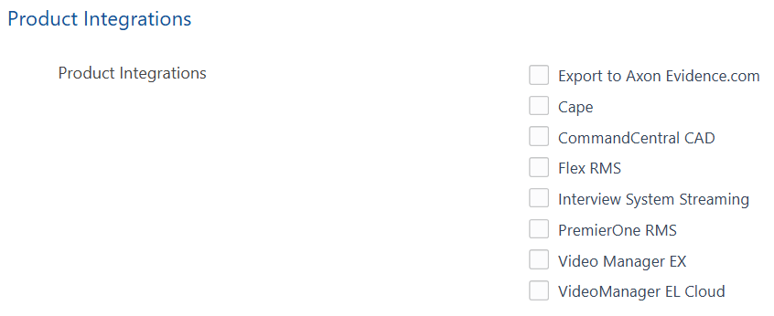

Professional Services
If deploying a mobile video solution with DEMS, mobile video deployment services are required. Choose the System Integration Calculation option based on the requirements below.

NOTE: These fields may be hidden if the “Are Video Deployment Services Needed?” toggle under the Model Selection is off.

System Integration Calculation
Choose 1 of the 3 options below:

Standard: For video quotes totaling less than or equal to $500K.
Custom: For video quotes totaling over $500K or an RFP response. This will require a PRR for a Pre-Sales Quote Review and SI Costs. The dollar amount given by the Pre-Sales team will be the input for the Deployment Services (total project dollars) field under the Video Deployment (SI) Services section.

None: Only Hardware Installation or other Optional Service is required.

CPQ Screenshot:
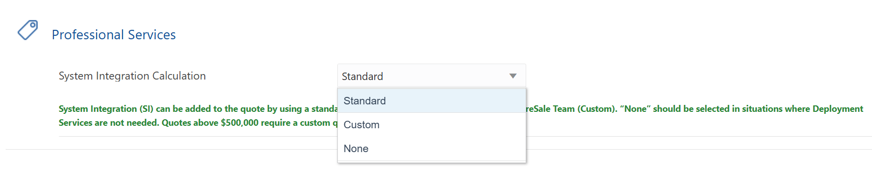

Deployment Type
Standard Deployment Options should only be utilized for quotes totaling <$500K. These options will only show if “Standard” is selected for System Integration Calculation.

Part Number | Description | Price | APC
PSV00S05487A | MOBILE VIDEO REMOTE CLOUD DEPLOYMENT  Standard Remote deployment for Body Camera only deployments. | $3,200 | 914
PSV00S05486A | MOBILE VIDEO ONSITE CLOUD DEPLOYMENT  Standard Onsite deployment for customers requiring on-site support. Includes remote project management support and virtual training by Global Education. | $8,999 | 914
PSV00S05490A | MOBILE VIDEO REMOTE EQUIPMENT ADD ON  Remote deployment for existing video customers adding on equipment only. | $1,299 | 914

CPQ Screenshot:
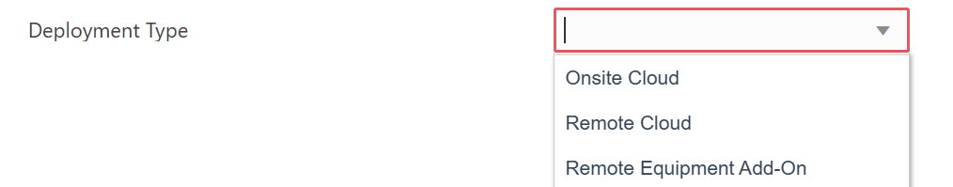

NOTE: There is a known error when you attempt to quote DEMS without a Mobile Video Deployment Service. Navigate back up to the Model Selection section, then toggle the “Are Video Deployment Services Needed?” ON. Then change the System Integration Calculation to “None”.
This issue will be resolved in a future CPQ release.

Deployment Options
Additional deployment options can be added to the Onsite Cloud, Remote Cloud and Remote Equipment Add-On deployment types as needed.

The pricing for these items will be included (rolled up) in the line-item price of the selection made under Deployment Type (Under the part number for the MOBILE VIDEO ONSITE CLOUD DEPLOYMENT, MOBILE VIDEO REMOTE CLOUD DEPLOYMENT, or MOBILE VIDEO REMOTE EQUIPMENT ADD ON). These deployment options will reflect an additional part number on the quote at zero dollars as seen in the example below.

Pricing Example:
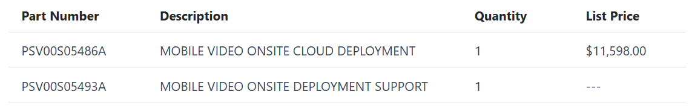

Part Number | Description | Price | APC
PSV00S05493A | MOBILE VIDEO ONSITE DEPLOYMENT SUPPORT  Additional Day of Onsite Support from the technician. Only applicable to the Onsite Cloud Deployment Option. | $2,599 | 914
PSV00S05491A | MOBILE VIDEO ONSITE TRAINING  Standard Onsite deployment includes Virtual Training only, add this option if Onsite Training is desired. | $4,499 | 914
PSV00S05492A | MOBILE VIDEO EQUIPMENT INVENTORY  Add this option if Onsite inventory of equipment is desired. | $5,099 | 914

CPQ Screenshot:
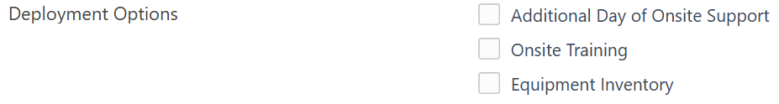

Video Deployment (SI) Services

Deployment Services (total project dollars)
Use this field to input the dollar amount for custom deployment services. This is required for video sales > $500K. An SI configurator will need to be completed by the Pre-Sale team which can be requested by submitting a PRR in Salesforce. Once the SI configurator is obtained from the Pre-Sale team, input the custom amount into the “Deployment Services (total Project Dollars)” field.

Mobile VIdeo SI Configurator:
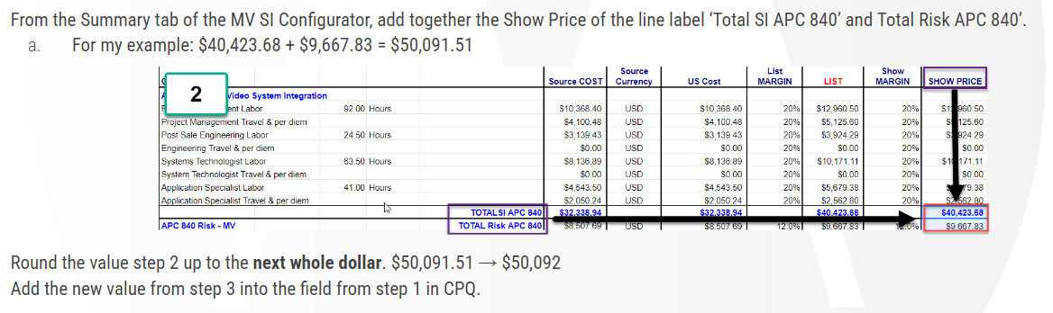

Part Number | Description | Price | APC
WGW00122-301 | MOBILE VIDEO DEPLOYMENT SERVICES  Custom SI; requires a PRR to request custom cost from a Pre-Sales PBM. Utilize the Deployment Services (total project dollars) field. | Quote Required | 840
CPQ Screenshot:
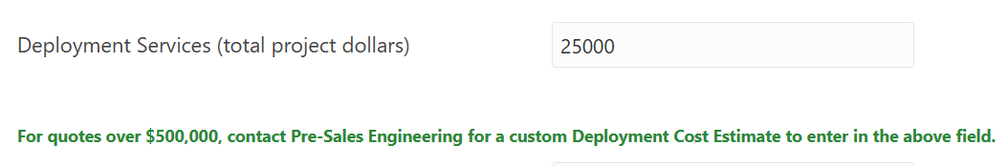

Deployment Services (Optional Selection)
Use the fields in this section for additional optional services.

Part Number | Description | Price | APC
WGW00121-200 | HARDWARE INSTALLATION  Requires quote from installation vendor. Input total from all applicable vendor quotes. | Custom  (Cost * $1.625) | 840
WGW00166-100 | REMOTE SERVICE EVIDENCE MIGRATION (per TB)  Internal data migrations from VMEL (EL4 or EL5 Only). | $125/TB | 840
ISV00S05494A | MOBILE DATA MIGRATION 3RD PARTY (per TB)  Data migration from 3rd Party vendors is no charge but amount of data is required to determine resource requirements. | $0 | 840
SSV07S03603A | MOBILE VIDEO SYSTEM ADMINISTRATOR - ONSITE  Fully dedicated to a customer and onsite. | $275,000 | 854
SSV07S03604A or SSV07S03605A | MOBILE VIDEO SYSTEM ADMINISTRATOR - REMOTE  Remote delivery / Shared dedicated team of resources amongst multiple customers. | 50 Hrs/Yr  =$9,000  100Hrs/Yr =$18,000 | 854

CPQ Screenshot:
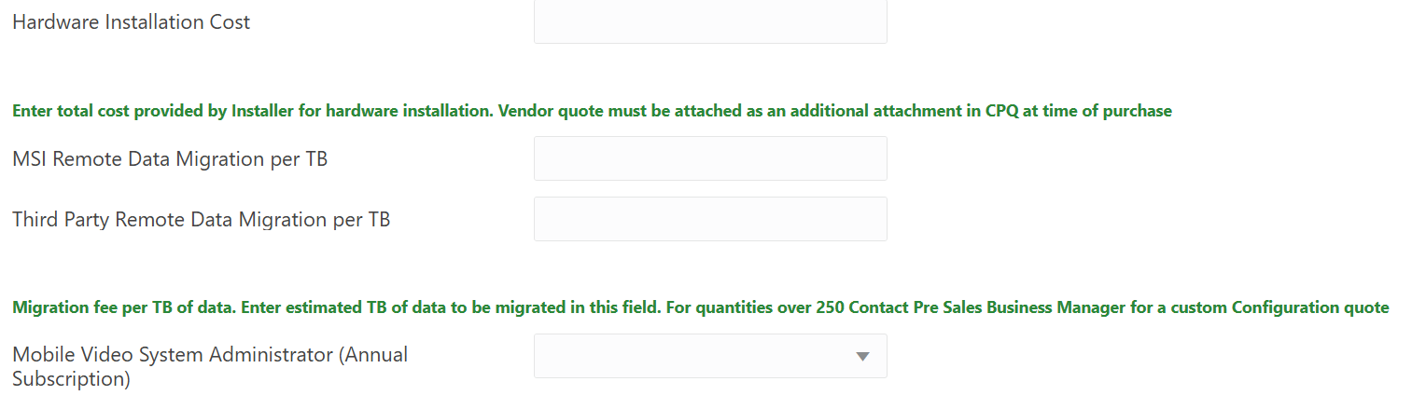

CommandCentral DEMS Training Services
These options are to add virtual or onsite training for the CommandCentral DEMS product. Quotes containing Mobile Video deployment services include training however this can be added if additional DEMS training is required.

Part Number | Description | Price | APC
PSV00S04239A | VIRTUAL TRAINING  8 Total Hours, 7 Hours of Customer Training* | $1,077 | 250
PSV00S04240A | ONSITE TRAINING  32 Total Hours, 24 Hours of Customer Training* | $7,540 | 250

CPQ Screenshot:
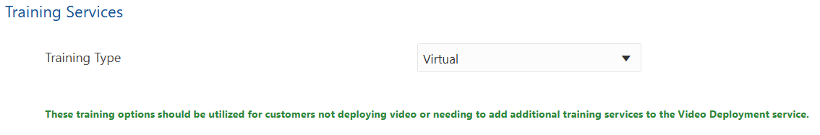

Learning Subscription
Customers can now access all online learning content across the MSI Ecosystem (all technology platforms) at no cost by simply creating an account. Therefore, there is no need to order a subscription just to gain access to the Learning Center.

Your customer can access advanced features like detailed learner management, intelligent grouping, streamlined training assignments, robust completion tracking, Bring Your Own Training (BYOT) content integration, and branded learning environments through our paid Premium Learning Subscription (SSV00S05484B). This subscription is ideal for organizations with complex training needs. For an in-depth understanding, listen to our 5 minute podcast to explore how these features can enhance your customers' training experience.

For more information, please contact Fabiola Castaneda with Global Education.

Part Number | Description | Price | APC
SSV00S05484B | PREMIUM LEARNING SUBSCRIPTION | $30.49/Month | 943

To order Premium Learning Subscriptions, enter the number of licenses required in the Learning Subscription field.

CPQ Screenshot:
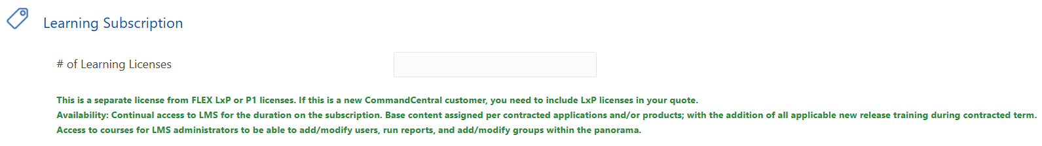

Premium Learning Subscription is a fee-based service that offers customers additional benefits and advanced functionalities. To learn more, please reference THIS DOCUMENT and the ORDERING GUIDE.

Required Order Information
This Parametric data is required to place an order but is optional for quoting. This information is used by the deployment teams to configure the product and communicate with the customer.

Agency Domain Name/ID - refers to the web address used by the agency (example.org)
Sales Contact Name for this order - First and Last Name of Sales Person
Sales Contact Email Address - Email Address for Sales Person
Entitlement Email Address - Customer POC receiving product communications
Admin Name - Technical Customer Contact
Admin Email Address - Technical Customer Email Address
Admin Phone Number - Technical Customer Contact Phone Number
Billing Option - Annual (Default)

CPQ Screenshot:
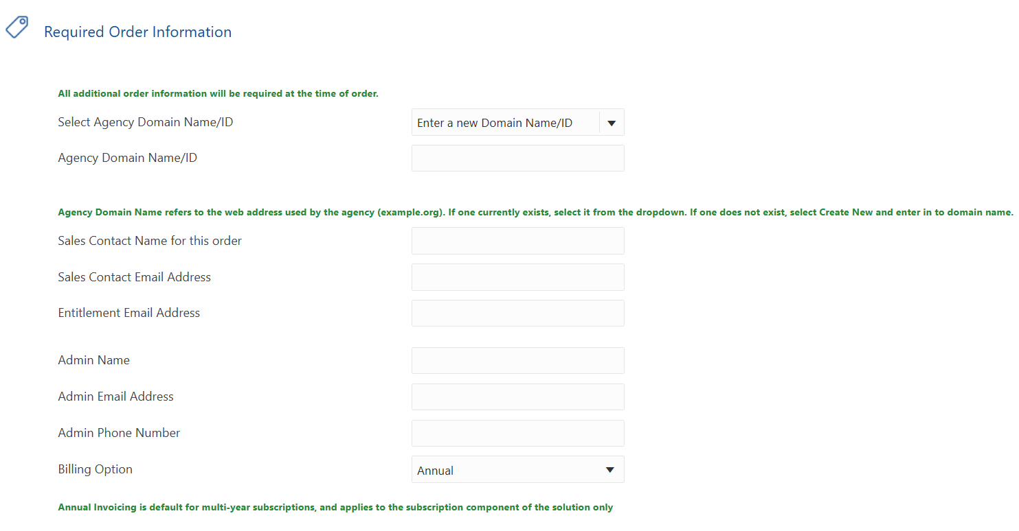

Interfaces (3rd Party Integrations)
Third-party integrations for DEMS may necessitate a custom quote from the Interfaces team if standard pricing is unavailable. These integrations also require an Interface Functional Description document (IFD) and an Edge Device may be necessary to deploy OnPrem CAD solutions.
Click here for details: 3rd Party CAD <> ELC to DEMS Transitions

DO NOT quote/order the VMEL API Item: WCM000111-010 for DEMS CAD Integrations. This will require a Change order and delays for your customer. This item is only to be used for 3rd Party access to the VMEL API.

When the proper part number(s) have been identified in the process linked above, follow the steps below to add them to a CPQ quote.

CPQ Tile:
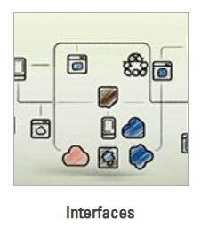

  - Solution Type: New
  - Select Subscription Duration
  - Module Type: Hybrid
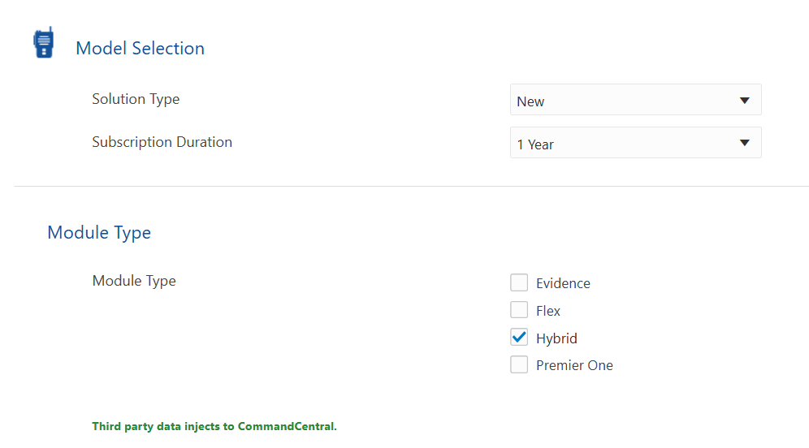

  - Select desired Interface from the Hybrid Interfaces list.
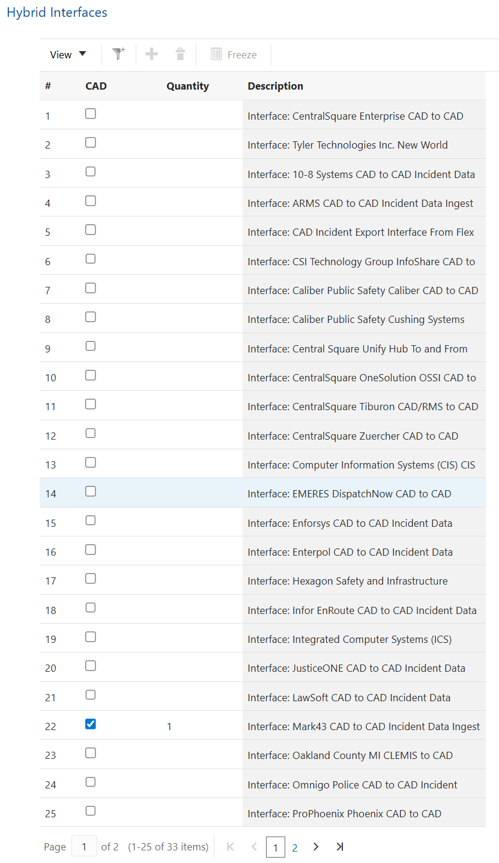

- Professional Services: Select Custom
  - Click Update at the top
  - Navigate to the SI COST tab to enter the deployment services total.
  - Enter a total of $5,366 SI Cost
    - 40hours (5 PM, 35 SA) at 2026 Rate

Step 1:
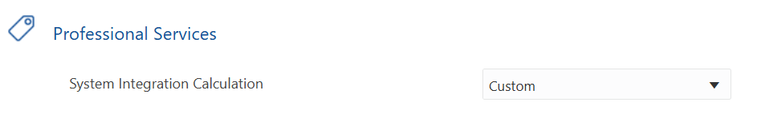
Step 2:
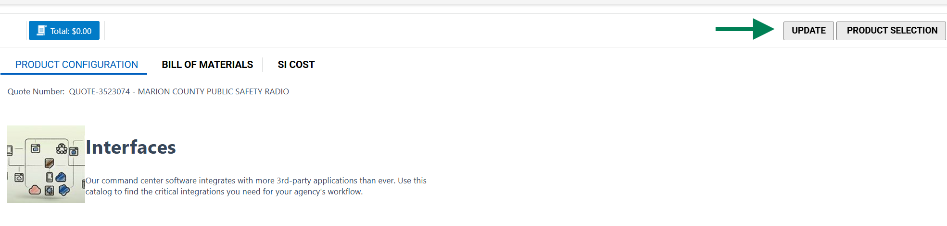
Step 3:

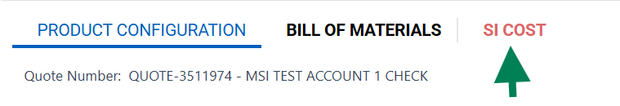
Step 4:

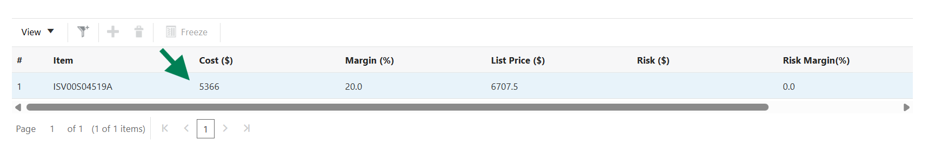

Edge Device Options
Determine if a CPS Edge device is needed for the customer. Interfaces which need to connect to 3rd party on-premises systems typically require a CPS Edge device, while interfaces which connect directly from MSI to the 3rd party cloud do not.
If the customer already owns a CPS Edge device which is hosting other interfaces, they do not need another Edge device. One Edge device can support multiple interfaces.
See the Evidence & Intelligence Interface Quoting & Development Process for more information.

If the customer requires new hardware, the order will include all four part numbers below (Total: $4,185). If using their own VM, only the two software parts are needed (Total: $3,145).

Hardware:
DS14767421 | HP ELITE MINI 800 G9 | $1,025
DS5929518 | Motorola Imaging special | $15
Software (for VM):
SSV00S05312A | 3rd Party Interface Edge Connector | $3,145
SSV01S05108A | RED HAT DEVICE EDGE WITH ENHANCED SUPPORT | $0

Use the Hardware section within the Interfaces tile to order the Edge Device components as shown below. Enter the quantity of Cloud Edge Platform with Hardware or Cloud Edge Platform Virtual Machine Only to add the part numbers above to your quote.

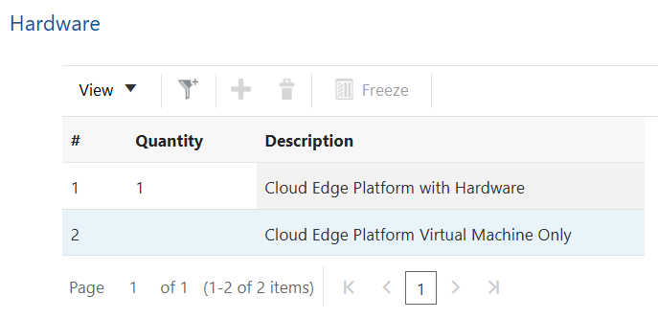

Final Parts list example shown below for a Mark43 CAD Interface with Edge Device Hardware.
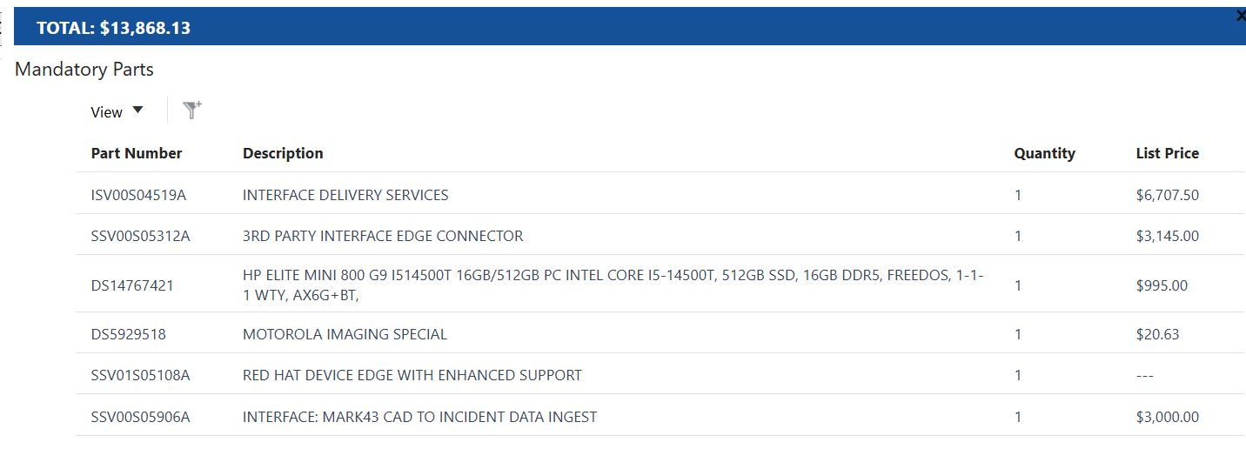

Accessories
Wireless access points and other additional hardware accessories are available for order under the Accessories tab.

CPQ Screenshot:
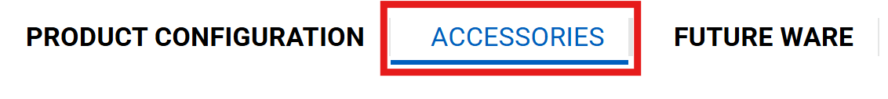
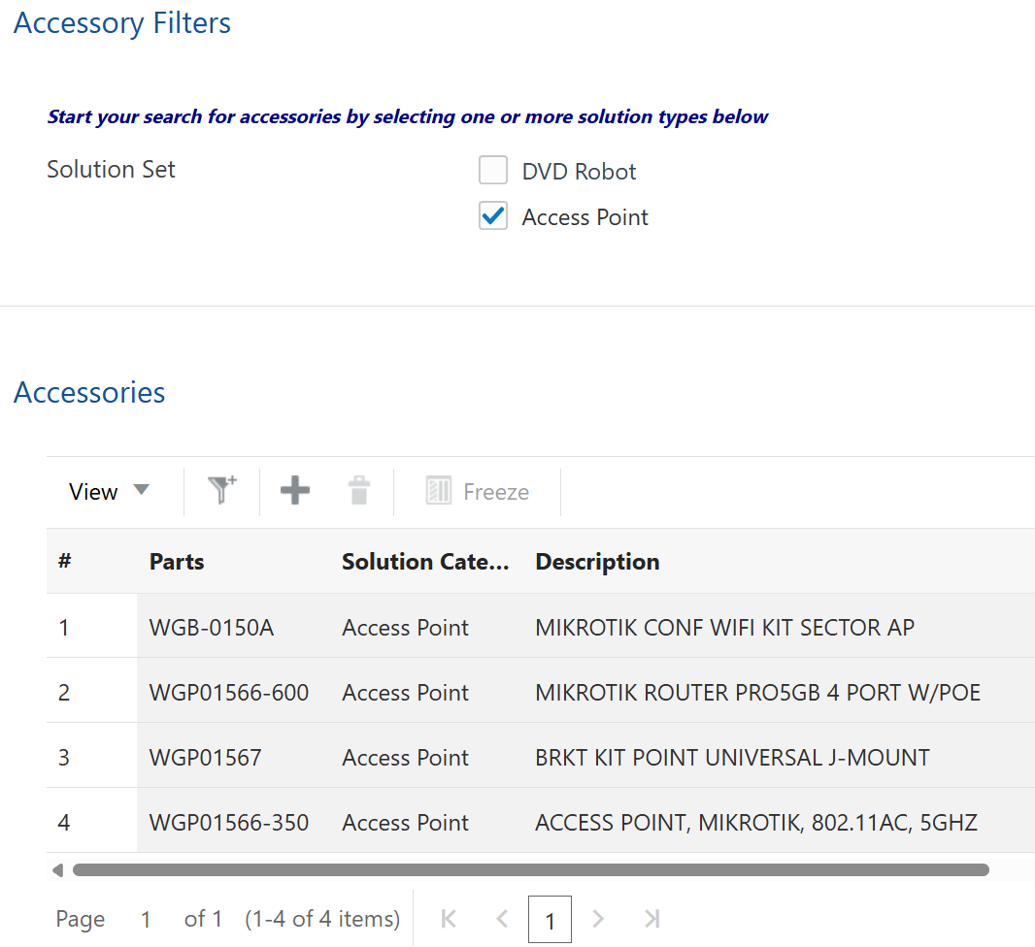

Helpful Links

CommandCentral DEMS Motorola Site

NA CPQ Training Guide: Body-Worn & In-Car Mobile Video

CommandCentral DEMS Internal Sales Guide

DEMS Internal Training & Resources

3rd Party CAD <> ELC to DEMS Transitions

Quoting Export to Axon - DEMS/VMEL

CommandCentral DEMS (SW only)_ISOW_NA_07May2025

CommandCentral DEMS Mobile Video Products_ISOW_NA_13May2025

MSAC (FedRAMP) DEMS Service Part Numbers:

Part Number | Description | Price | APC
SSV00S06298A | STARTER - FEDRAMP  Search, View, Download files, Collections Lite | $0 | 696
SSV00S06301A | STANDARD - FEDRAMP  Device Management, Collections, Sharing, Redaction (manual), SmartControl, 1P CAD Auto Tagging, Responder Light | $20/ Device/ Month | 696
SSV00S06302A | PLUS - FEDRAMP  3rd Party Data Upload, AI Redaction, AI Auto Transcription, Automated Access Management | $33/ Device/ Month | 696
SSV00S06299A | DEVICE MANAGEMENT ONLY - FEDRAMP  Used only for SVX RSM Only Customers.  Includes PSV00S05316A SmartDock Config Service @ $0 | $0 | 696

CCCS DEMS Service Part Numbers:

Part Number | Description | Price | APC
SSV00S06303A | STARTER - CCCS  Search, View, Download files, Collections Lite | $0 | 696
SSV00S06306A | STANDARD - CCCS  Device Management, Collections, Sharing, Redaction (manual), SmartControl, 1P CAD Auto Tagging, Responder Light | $20/ Device/ Month | 696
SSV00S06307A | PLUS - CCCS  3rd Party Data Upload, AI Redaction, AI Auto Transcription, Automated Access Management | $33/ Device/ Month | 696
SSV00S06304A | DEVICE MANAGEMENT ONLY - CCCS  Used only for SVX RSM Only Customers.  Includes PSV00S05316A SmartDock Config Service @ $0 | $0 | 696

